From Endpoint statistics, 192.168.15.4 Could be router as many requests are being forwarded through this IP. Highest number of packets being processed by this IP.
Lily received 2 emails, one from sendanonymousemail.com(pckt: 80614) other from willselfdestruct.com (pck: 90426).

For willselfdestruct.com : (http && frame contains "willself")
J sessionId: JSESSIONID=C16BFAC8710DA82AB3D8D80AE0F4F05A (pckt : 83604)
User agent: Mozilla/4.0 (compatible; MSIE 6.0; Windows NT 5.1; SV1)
Src: 192.168.15.4 :::: Dst: 69.25.94.22
Client ca pub id : client=ca-pub-1112722574718853
Result :- Checked for later packets but found no other session with incriminating info.

For packet to sendanonymousemail.com, we have following parameters: (http && frame contains "senda")
PHPsessionID: PHPSESSID=762adba03236142ccec305f6a20aaffa (Of the form which sent the abuse email)
User agent: Mozilla/4.0 (compatible; MSIE 6.0; Windows NT 5.1; SV1)
Src: 192.168.15.4 :::: Dst: 69.80.225.91

The guy before accesing the sendanonymous email, first searched for the website in google, google used cookie to track it’s users.
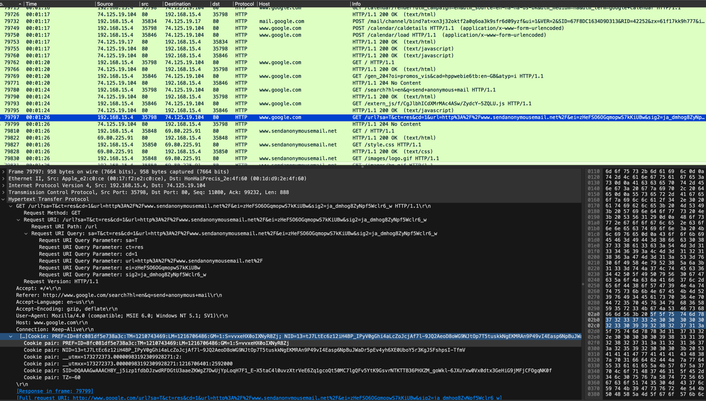

Cookie: Session ID : SID=DQAAAGwAAACH8Y_j5izp1fdbDJzwdRFDGtU3aaeZKWgZ7DwUjYpLoqH7F1_E-X5taC4l0uvzXtrVeE6Zq1gcoQt50MC7lgQFv5YtK9GsvrNTKTTB36PHXZM_goWkl-6JXuYxw0Vx0dtx3GeHiG9jMFjCFOgqNK0f

Then we can see the site sendanonymousemail.com is being accessed same user agent (Mozilla/4.0 (compatible; MSIE 6.0; Windows NT 5.1; SV1))

With the same session the guy accessed their gmail page, here we can see the same PREF=ID && session ID cookie exactly same as the google search cookies. Here we can see their email as a cookie.
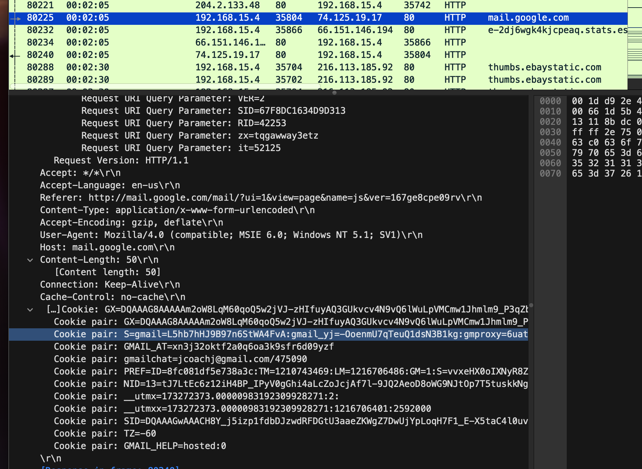

- So, we can conclude safely that jcoach@gmail.com is the culprit, who sent those emails. From the list of students, we can infer that the student name must be “Johnny Coach”.

